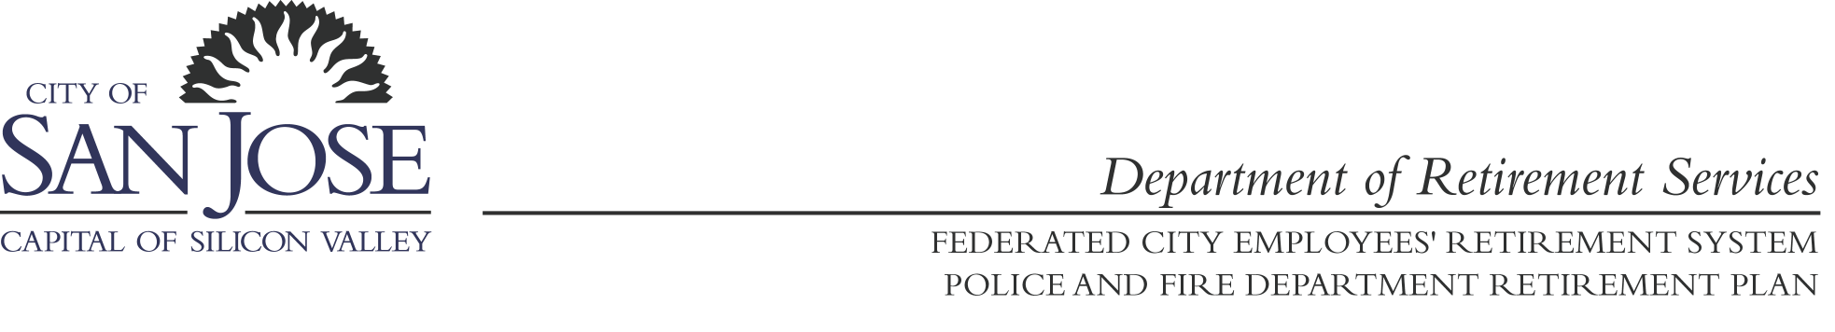

Board of Administration
Federated City Employee’s Retirement System/
Police and Fire Department Retirement Plan

TAX QUALIFICATION REVIEW – JOINT SPECIAL MEETING

Department of Retirement Services
1737 N. First Street
6th Floor Board Conference Room
San Jose, CA 95112

POLICE & FIRE BOARD FEDERATED BOARD DIRECTOR
David Bacigalupi, Chair Matt Loesch, Chair Russell Crosby
Conrad Taylor, Vice Chair Ed Overton, Vice Chair
Rose Herrera, Trustee Pete Constant, Trustee
Scott Johnson, Trustee Ash Kalra, Trustee
Sean Kaldor, Trustee Jeffrey Perkins, Trustee
Sam Liccardo, Trustee Arn Andrews, Trustee
Vacant, Trustee Vacant, Trustee

WEDNESDAY OCTOBER 20, 2010 9:00 A.M.

AGENDA

WELCOME AND INTRODUCTION
Mary Beth Braitman, Ice Miller LLP, outside tax counsel

I Top Substantive Issues for Tax Qualification of Governmental Defined Benefit Pension
Plans

II Internal Revenue Service Preferred Technical Language in Governmental Defined Benefit Pension Plans and Optional Provisions

BREAK

III Tax Determination Letter Process and Voluntary Compliance Program
Pros and Cons
Next Steps

IV Concluding Remarks

PUBLIC COMMENT – Matters not on Joint Study Session Agenda

ADJOURNMENT

